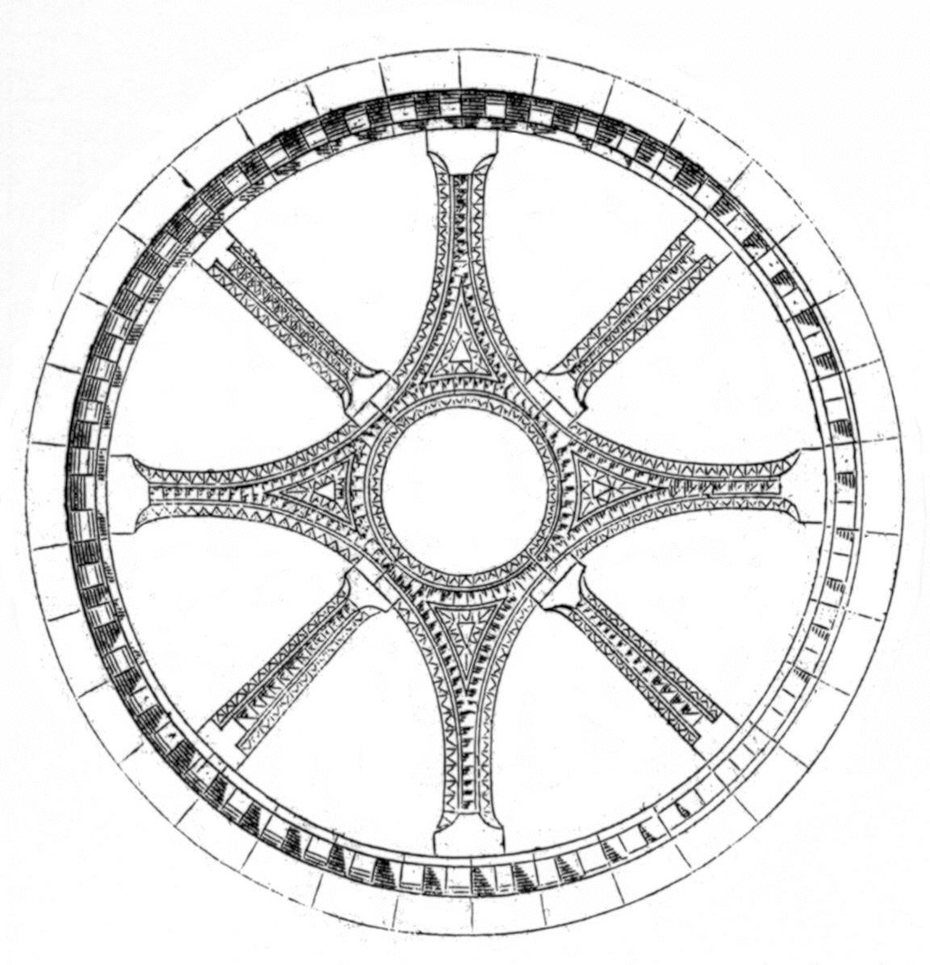
International Medieval Society - Paris
Symposium 2006: “Foreigners, Strangers, and Others in Medieval France”
29 June – 1 July 2006, École nationale des chartes, Paris

Name:

Affiliation:

Address:

E-mail:

Please indicate your response to the following by circling the appropriate answer.

• I would OR would not like to be added to the IMS Members e-mail listserv (ims-members@yahoogroups.com).

• I would OR would not like to attend the visit to medieval Paris buildings on Saturday afternoon, 1 July.

• My registration fee is enclosed (checks made payable to Société Internationale des Médiévistes) OR I will pay my registration fee in cash at the beginning of the Symposium. Please note that registration fee must be in Euros. If you do not have a Euro currency bank account, simply pay in cash at the Symposium.

Registration Fee Schedule (includes 1 year membership to the International Medieval Society)
35 euros: regular rate
25 euros: reduced rate for students, emeriti/ae, independent scholars
100 euros or more: Friends of the Society

Please enclose your check in euros with this registration form. If you do not have a euro bank account, you may pay in cash when you arrive at the Symposium. Registration will not be considered complete until you fee is received.

Please mail this completed form no later than 1 May to
Société Internationale des Médiévistes
Xavier Dectot
Musée national du Moyen Âge
6, place Paul Painlevé
75005 Paris, FRANCE

